Ch5 数字滤波器设计

巴特沃斯模拟滤波器振幅特性与对阶数N的依赖关系

课本P178 图2 -23

clear;

close all;

clc;

%--------------------------------------------------------------------------

%官网程序，幅度按dB，叠加显示

%--------------------------------------------------------------------------

figure;

N = 6;

for n = 1:N

[z, p, k]=buttap(n);

[num,den] = zp2tf(z,p,k);

W = logspace(-1,1);

freqs(num,den,W) % Frequency response of analog filter

hold on;

hs = tf(num,den);

%课本 P179 表5-1；但归一化Wc

%打印输出显示阶数

disp(n);

%打印输出显示分子

disp(num);

%打印输出显示分母

disp(den);

%打印输出显示系统函数

hs;

end

1

0 1

1 1

2

0 0 1

1.0000 1.4142 1.0000

3

0 0 0 1.0000

1.0000 2.0000 2.0000 1.0000

4

0 0 0 0 1

1.0000 2.6131 3.4142 2.6131 1.0000

5

0 0 0 0 0 1

1.0000 3.2361 5.2361 5.2361 3.2361 1.0000

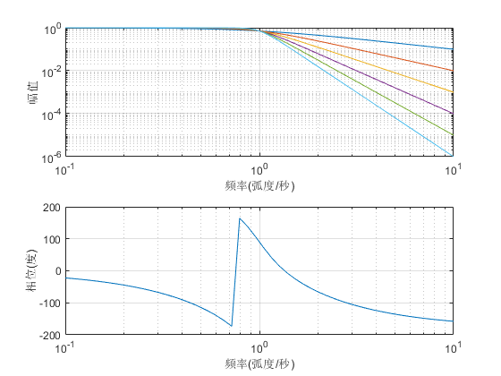

6

0 0 0 0 0 0 1

1.0000 3.8637 7.4641 9.1416 7.4641 3.8637 1.0000

%--------------------------------------------------------------------------

%在官网程序基础上，幅度按线性，叠加显示

%--------------------------------------------------------------------------

figure;

N = 6;

str = ["N=1","N=2","N=3","N=4","N=5","N=6"];

for n = 1:N

[z, p, k]=buttap(n);

[num,den] = zp2tf(z,p,k);

w = linspace(0, pi);

h = freqs(num,den,w);

mag = abs(h)/abs(h(1));

dbmag = 20\*log10(mag);

phase = angle(h); %输出scale:-pi~pi

degphase = phase\*180/pi; %转为degree

subplot(3,1,1), plot(w/pi,mag)

xlabel('频率');

ylabel('振幅');

title('巴特沃斯滤波器振幅特性对阶数N的依赖关系')

grid on;

hold on;

subplot(3,1,2), plot(w/pi,dbmag)

xlabel('频率');

ylabel('振幅 dB');

title('巴特沃斯滤波器振幅特性对阶数N的依赖关系')

grid on;

hold on;

subplot(3,1,3), plot(w/pi,degphase)

xlabel('频率');

ylabel('相位');

title('巴特沃斯滤波器相位特性对阶数N的依赖关系')

grid on;

hold on;

end

legend(str(1),str(2),str(3),str(4),str(5),str(6));

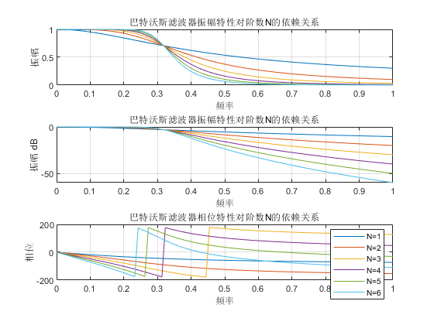

%--------------------------------------------------------------------------

%单独把幅度拿出来显示

%--------------------------------------------------------------------------

figure;

N = 6;

str = ["N=1","N=2","N=3","N=4","N=5","N=6"];

for n = 1:N

[z, p, k]=buttap(n);

[num,den] = zp2tf(z,p,k);

w = linspace(0, pi);

h = freqs(num,den,w);

mag = abs(h)/abs(h(1));

dbmag = 20\*log10(mag);

phase = angle(h); %输出scale:-pi~pi

degphase = phase\*180/pi; %转为degree

plot(w/pi,mag)

xlabel('频率');

ylabel('振幅');

title('巴特沃斯滤波器振幅特性对阶数N的依赖关系')

grid on;

hold on;

end

legend(str(1),str(2),str(3),str(4),str(5),str(6));

